Author Name: Dilip Parmar
PI: C5552003
Module: TT284 Web Technologies
Assignment Number: TMA 01
Dated: 20th March 2013

Part 1: Making the prototype site usable and standards-compliant

The short report
(a) Write a few short paragraphs describing how you have amended the html templates to ensure the usability of the prototype for the Open University Running Club website.
The maximum word count for Part 1(a) is 400 words.
(35 marks)
(b) In your own words, describe your understanding of both valid XHTML and valid CSS and explain the nature of the changes you made to the files provided to achieve standards-compliant coding of the prototype website.
The maximum word count for Part 1(b) is 400 words.
(35 marks)

Making the Prototype Site Usable

Client Requirements
The clients’ requirement for the design task is as follows:
- Getting performance data online rapidly.
- User should be able to navigate between ‘home page’ and ‘runner data page’ without having to resort to using the browser back button.
- Link the HTML and CSS files.
- Correct errors in the CSS file.
- The HTML and CSS files to be standards compliant.
- Accessibility and disadvantaged users catered for and thoughts on accessibility.
- ‘Think about’ access to data by users on the move.
- At this stage the client does not require any re-styling of the home page or other links.

Files for Modification
The following three files were provided by the client:
- ourc_index.htm
- ourc_data.htm
- ourc_global.css

Browser Details and Testing
The Mozilla Firefox browser version 19.0.2 was used to load and test the files. The following tests were successfully conducted:
- Use of ‘zoom in’ and ‘zoom out’ functions.
- Navigating between ‘home page’ and ‘runner data page’ without having to resort to using the browser back button, for the browser response layouts below:
  - Mobile portrait (320x480)
  - Mobile landscape (480x320)
  - Small tablet portrait (600x800)
  - Small tablet landscape (800x600)
  - Tablet portrait (768x1024)
  - Tablet landscape (1024x768)

Other Resources Utilised
Using the W3C Markup validation Service (W3C) the web pages were validate as XHTML 1.0 strict.
The style file was validated as CSS (level 2.1) using the W3C CSS Validation Service (W3C).

Additional Accessibility Work Required
At this stage I have not implemented the ability for screen readers to scan text data in tables.

ourc_index.htm
The W3C markup validation service initially checked this document and returned HTML 4.01 Transitional with the following result:
- 4 errors.
- 12 warnings
After correction the document was successfully checked as XHTML 1.0 Strict! And returned one warning due to – Using Direct Input mode: UTF-8 character encoding assumed.
Details of the changes are provided as ‘comments’ in the htm document.

ourc_data.htm
The W3C markup validation service checked this document and returned HTML 4.01 Transitional with the following result:
- 1 errors.
- 4 warnings
After correction the document was successfully checked as XHTML 1.0 Strict! and returned one warning due to - Using Direct Input mode: UTF-8 character encoding assumed.
Details of the changes are provided as ‘comments’ in the htm document.

ourc_global.css
The W3C CSS validation service checked this TextArea for CSS level 2.1 and returned the following result:
- 5 errors.
- 0 warnings
After the changes described below the document was successfully checked and returned - Congratulations! No Error Found.
Details of the changes are provided as ‘comments’ in the CSS file.

Meeting the Client Requirements
Based on the work undertaken there is a high degree of confidence that the Client’s requirements have been met.

Browser Statistics
The browser statistics provided below support Firefox as a reasonable choice to use as a test bed, additionally the client is advised to conduct trialling on IE and Chrome.
The current W3C browser statistics are:
2013 | Internet Explorer | Firefox | Chrome | Safari | Opera
February | 13.5 % | 29.6 % | 50.0 % | 4.1 % | 1.8 %
January | 14.3 % | 30.2 % | 48.4 % | 4.2 % | 1.9 %

The Statcounter site reports the following statistics for the UK:
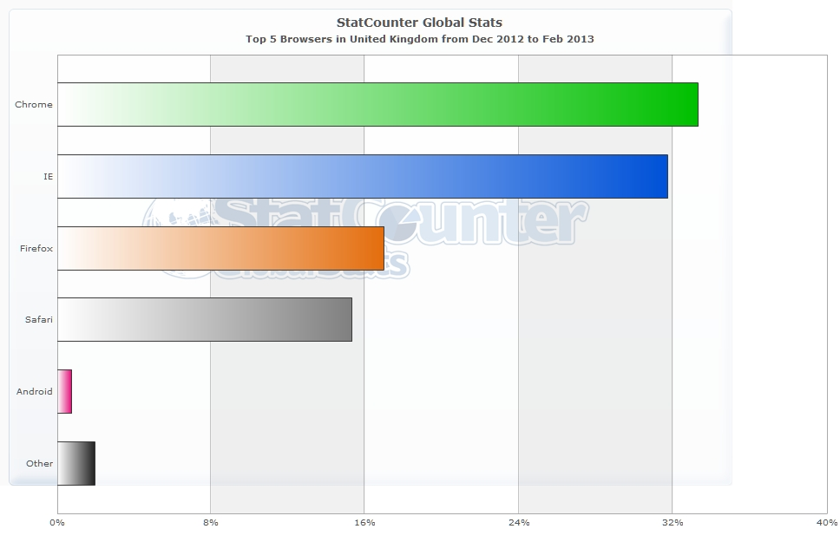

Valid XHTML
From Wikipedia; ‘An XHTML document that conforms to an XHTML specification is said to be valid. Validity assures consistency in document code, which in turn eases processing, but does not necessarily ensure consistent rendering by browsers. A document can be checked for validity with the W3C Markup Validation Service’. This service has been used to validate the OURC html files and identify changes.

Valid CSS
The purpose of CSS is to manage the document presentation, whilst XHTML deals with the document content. This separation has the benefits of enabling multiple web pages to share the same presentation approach and for the same data different to be linked to a number of CSS to support a range of browsers and rendering methods. A CSS can be checked for validity with the W3C CSS Validation Service. This service has been used to validate the OURC CSS and identify changes.

References

Statcounter (n.d.) ‘Browser statistics for the last three months’ [online] http://gs.statcounter.com/export/FCExporter.php (accessed 19/03/2013).

Wikipedia (n.d.) ‘XHTML’ [online] http://en.wikipedia.org/wiki/XHTML (accessed 20/03/2013).

W3C (n.d.) ‘Markup Validation Service’ [online] http://validator.w3.org/ (accessed 19/03/2013).

W3C (n.d.) ‘CSS Validation Service’ [online] http://jigsaw.w3.org/css-validator/ (accessed 19/03/2013).

W3C (n.d.) ‘Browser usage statistics as at February 2013’ [online] http://www.w3schools.com/browsers/browsers_stats.asp (accessed 19/03/2013).

Part 2: Considering the accessibility of the prototype
In this second part of the TMA you are now asked to consider the accessibility of the Open University Running Club prototype templates. In practical terms, this now means considering different visitors to the website and how they might access the website and in considering the accessibility of the site, you might also find it useful to consider how visitors access the running data.
For this part you will find the case study accessibility videos a useful starting point for your solution.
The maximum word count for Part 2 of your report is 350 words.
(30 marks)

Web Accessibility
The World Wide Web Consortium (W3C) launched the International Programme Office (IPO) for the Web Accessibility Initiative (WAI) in October 1997. According to the W3C, the task of the WAI is to promote and achieve web functionality for people with disabilities.
Web accessibility should also be considered for older users, areas with poor connectivity and mobile users.

Standards
To support web accessibility, the W3C standard titled Web Content Accessibility Guidelines 2.0 (WCAG 2.0), (W3C, 2008) discusses the four principles of accessibility (Perceivable, Operable, Understandable and Robust), which are supported by a list of guidelines. Each guideline in turn has a number of success criteria, and associated with the criteria are techniques classified as sufficient or advisory to help develop an accessible website.
For the OURC the WCAG 2.0 level of conformance is the priority level 2.
Additionally for the OURC the in-house OU On-Line Style guide called On line ICE (OU) should also be followed but primacy should be for WCAG 2.0.

Legislation
International and National legislation exists to support web accessibility:
- The UN Convention on the Rights of Persons with disability recognises access to information and communication technologies, including the Web as a basic human right (United Nations).
- The UK Equality Act 2010 and Special Education Needs and Disability Act 2001 (UK Government) are national legal requirements.

Business Benefits of Accessibility
Case studies for the Legal & General Group, and Tesco support the case for an accessible website in terms of business benefit from increased business, lower running costs and positive company reputation. An example of negative reputation resulting from a poorly designed website is the Sydney Olympic Games website. These case studies are available as part of a W3C toolset for building the accessibility business case (W3C).

Designing for Smart Phones and Mobile Devices
The longer term aim of the OURC is to provide a service to mobile users via a range of hand held devices. Microsoft, 2010 have produced a paper titled ‘Designing Web Sites for Phone Browsers’, which discusses the design considerations in the context of mobile browsers, detecting browser type, adapting for mobile browsers and targeting mobile browsers.

My Own Definition of Accessibility
My own definition of accessibility is:
‘Access to information by any person, using any device, with any browser, at any location and any time’.
The aim should be to design for accessibility from the outset.

References

Microsoft Corporation (April 2010) ‘Designing Web Sites for Phone Browsers’ Revision 2.0.

United Kingdom Government (n.d.) ‘Equality Act Guidance’ [online] https://www.gov.uk/government/publications/equality-act-guidance (accessed 19/03/2013)

United Nations (n.d.) ‘UN Convention on the Rights of Persons Disabilities [online] http://www.un.org/disabilities/convention/note.shtml (accessed 19/03/2013)

OU (n.d.) ‘OU ICE On-Line Style’ [online] http://www.open.ac.uk/webstandards/v3.0/index.php (accessed 19/03/2013)

W3C (n.d) ‘Web Accessibility Initiative’ [online] http://www.w3.org/WAI/ (accessed 19/03/2013)

W3C (n.d) ‘Building a Web Accessibility Business Case’ [online] http://www.w3.org/WAI/bcase/Overview (accessed 19/03/2013)

W3C (2008) ‘Web Content Accessibility Guidelines 2.0’ [online] http://www.w3.org/TR/WCAG20/ (accessed 19/03/2013)

